Install Maven:
Open CMD Prompt and check the Java Version:
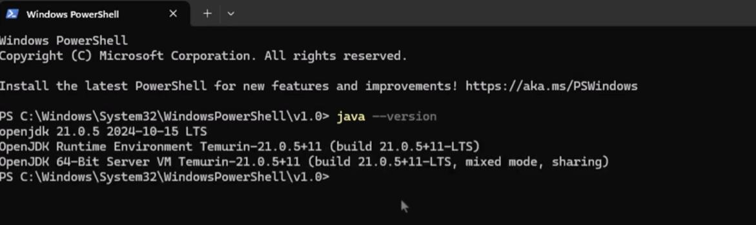
Go to APACHE MAVEN: https://maven.apache.org/download.cgi
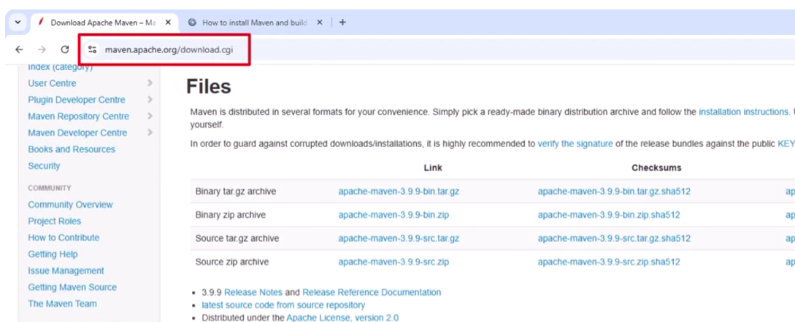

- DOWNLOAD APACHE-MAVEN BIN.ZIP
- SAVE IT UNDER THE SAME FOLDER THAT YOU HAVE YOUR JDK INSTALLED
- EXTRACT ALL IN THAT SAME FOLDER
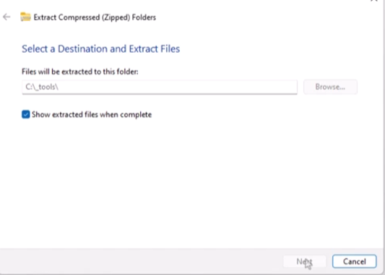
- COPY FULL PATH OF THE BIN DIRECTORY
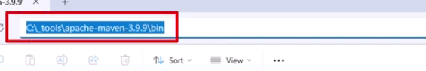

- EDIT THE ENVIRONMENT VARIABLE
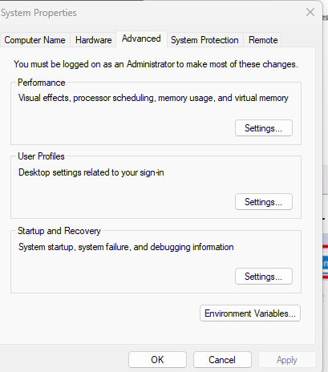
- CLICK ON ENVIRONMENT VARIABLE
- CLICK ON PATH AND EDIT:
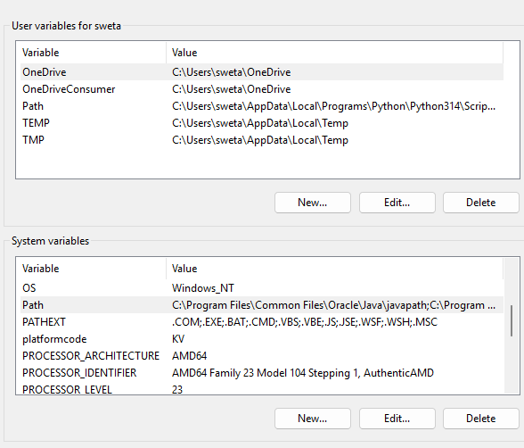

- CLICK ON NEW AND PASTE THE PATH OF THE MAVEN BIN AND CLICK ON OK
- Then ON THE ENVIRONMENT VARIABLE SCREEN CLICK ON NEW ENTER VARIABLE NAME AS MAVEN_HOME, VARIABLE VALUE: PASTE THE SAME LINK AND REMOVE BIN FROM THAT LINK
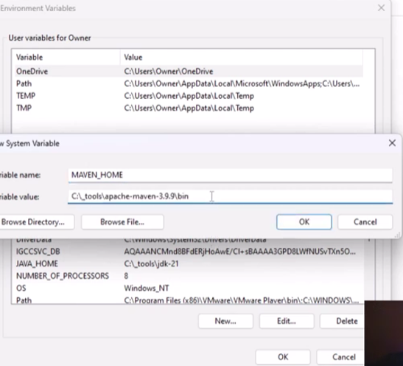
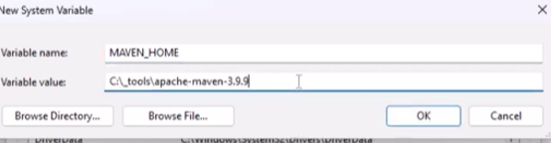

SAME WAY AGAIN CLICK ON NEW AND ADD VARIABLE NAME AND VALUE AS FOLLOWS – REMOVE BIN FROM THE VARIAVLE VALUE LINK:
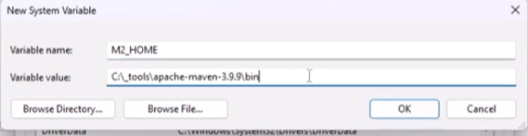
GO BACK TO COMMAND PROMPT AND TYPE mvn --version
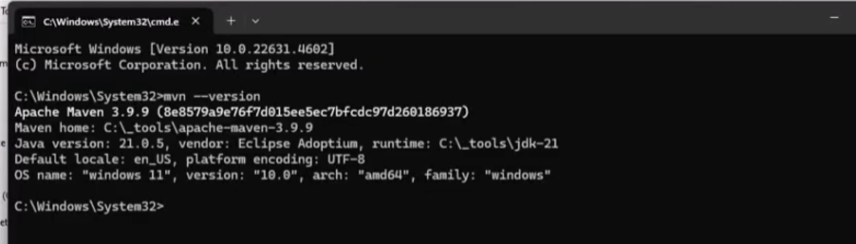
SO MAVEN IS SUCCESSFULLY INSTALED.

CONFIGURE MAVEN IN JENKINS:
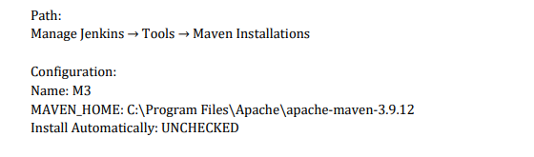
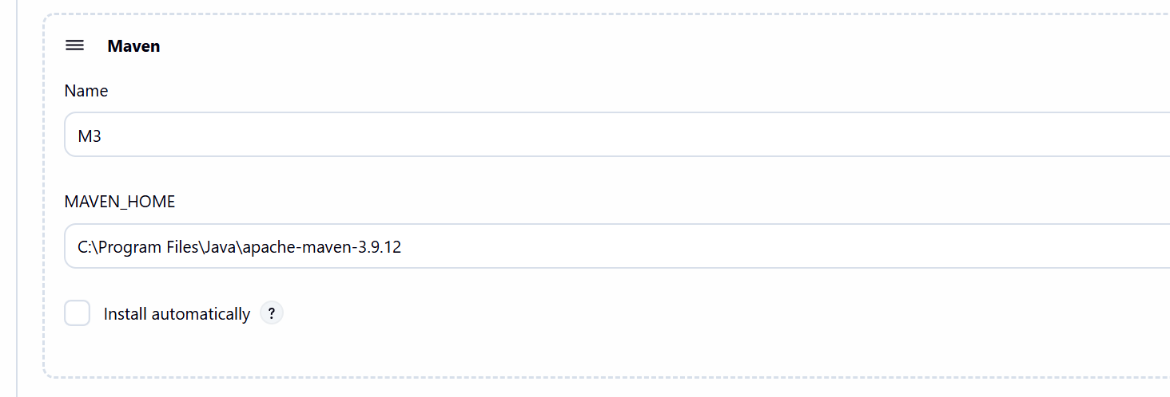

NOW LETS OPEN GITHUB

- CREATE A NEW REPOSITORY: SIMPLE-MAVEN-APPLICATION
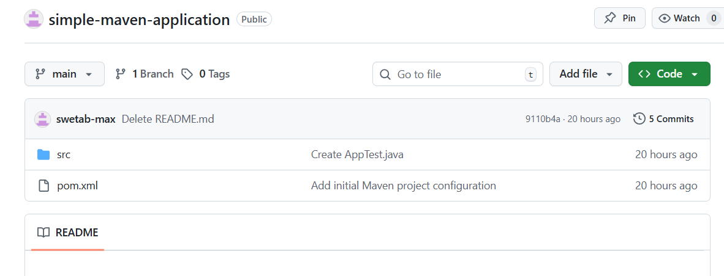
Create a file – pom.xml
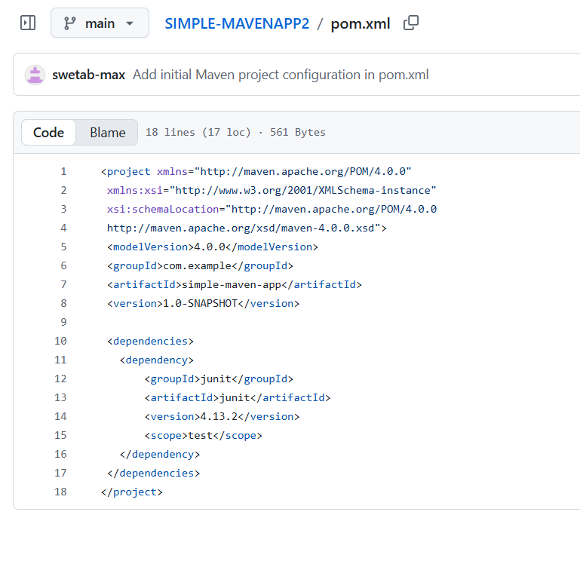
CODE:
<project xmlns="http://maven.apache.org/POM/4.0.0"
xmlns:xsi="http://www.w3.org/2001/XMLSchema-instance"
xsi:schemaLocation="http://maven.apache.org/POM/4.0.0
http://maven.apache.org/xsd/maven-4.0.0.xsd">
<modelVersion>4.0.0</modelVersion>
<groupId>com.example</groupId>
<artifactId>simple-maven-app</artifactId>
<version>1.0-SNAPSHOT</version>

<dependencies>
<dependency>
<groupId>junit</groupId>
<artifactId>junit</artifactId>
<version>4.13.2</version>
<scope>test</scope>
</dependency>
</dependencies>
</project>
COMMIT THE CHANGES

THEN CREATE THE FOLLOWING FOLDER STRUCTURE

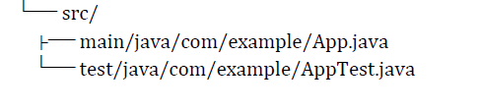\
FOR THE APP.JAVA PLEASE USE THE FOLLOWING CODE:
package com.example;
public class App {
public int add(int a, int b) {
return a + b;
}
}
COMMIT THE CHANGES

FOR THE AppTest.JAVA use the FOLLOWING CODE:
package com.example;
import org.junit.Test;
import static org.junit.Assert.*;
public class AppTest {
@Test
public void testAdd() {
App app = new App();
assertEquals(5, app.add(2, 3));
}
}
COMMIT THE CHANGES

THEN OPEN VSCODE:
- CLONE YOUR GIT REPOSITORY IN VSCODE
- In the TERMINAL type command: mvn clean test

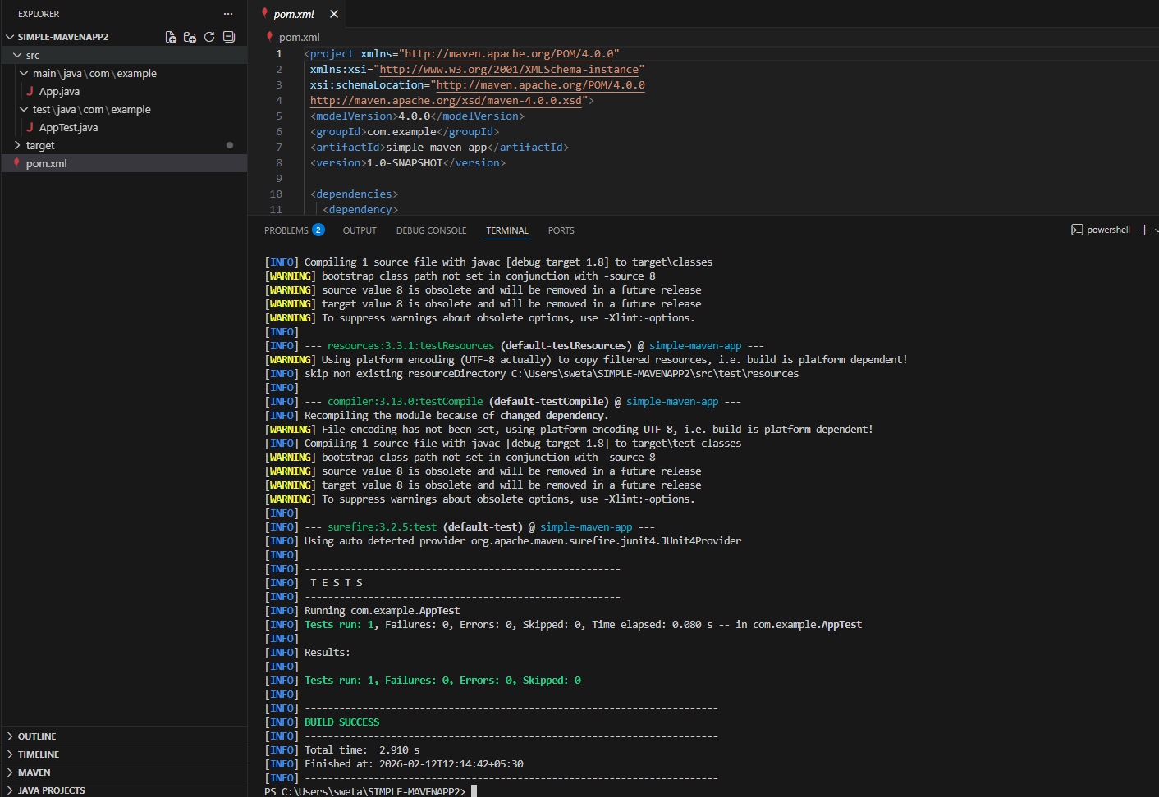
IT SHOULD SHOW THAT BUILD IS SUCCESSFUL

NOW OPEN JENKINS:

- NEW ITEM
- ENTER NAME AND SELECT PIPELINE
- CLICK OK
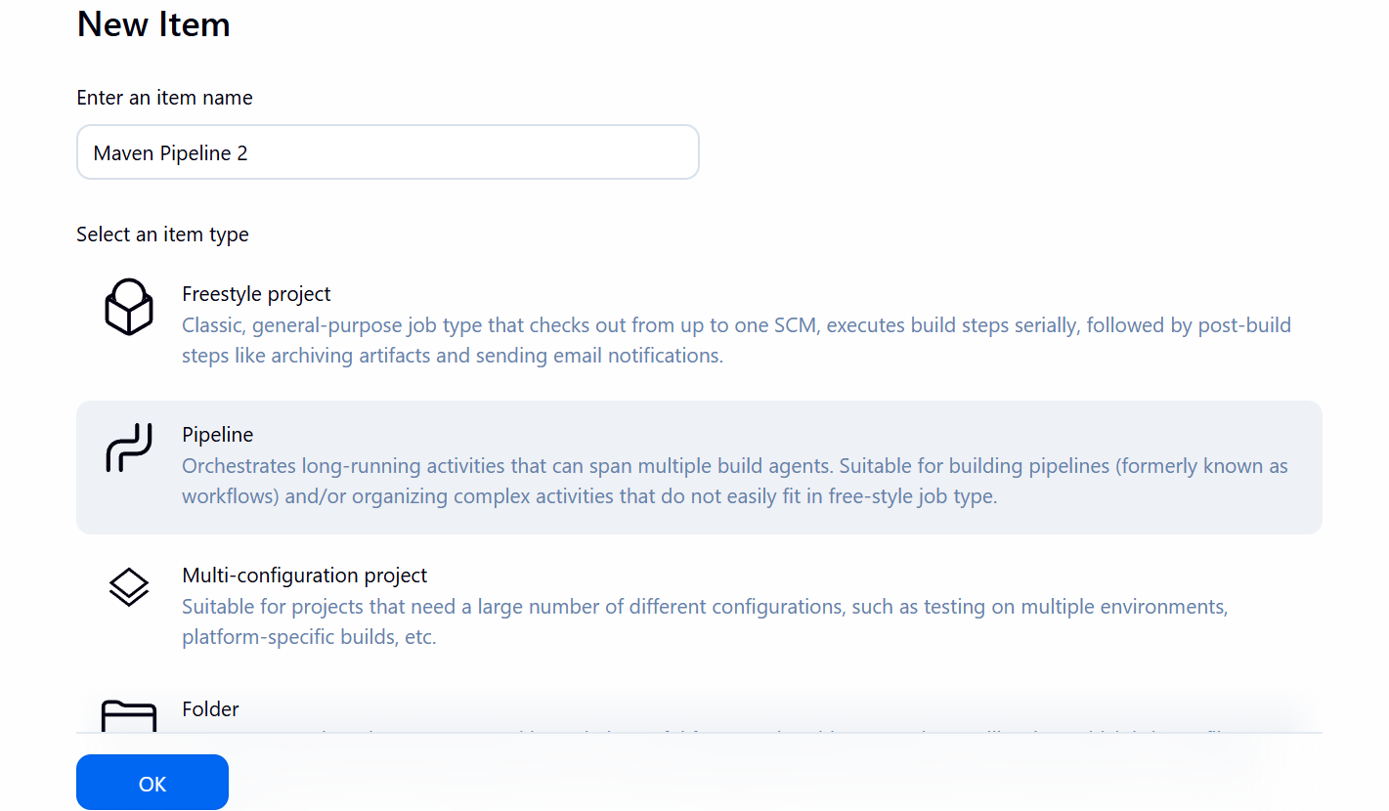

IN THE PIPELINE SCRIPT ADD THE FOLLOWING CODE:

pipeline {
agent any
tools {
maven 'M3'
}
stages {
stage('Checkout Git') {
steps {
git branch: 'main',
url: 'https://github.com/balaganeshn/simple-maven-app'
}
}
stage('Build and Test') {
steps {
bat 'mvn clean test'
}
}
}
}
UPDATE THE GITHUB url TO YOUR REPOSITORY URL:

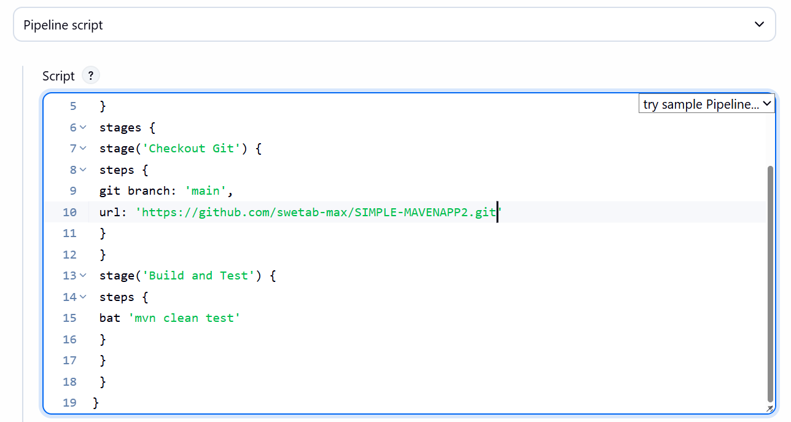
CLICK APPLY AND SAVE, IN THE NEXT SCREEN CLICK ON BUILD NOW
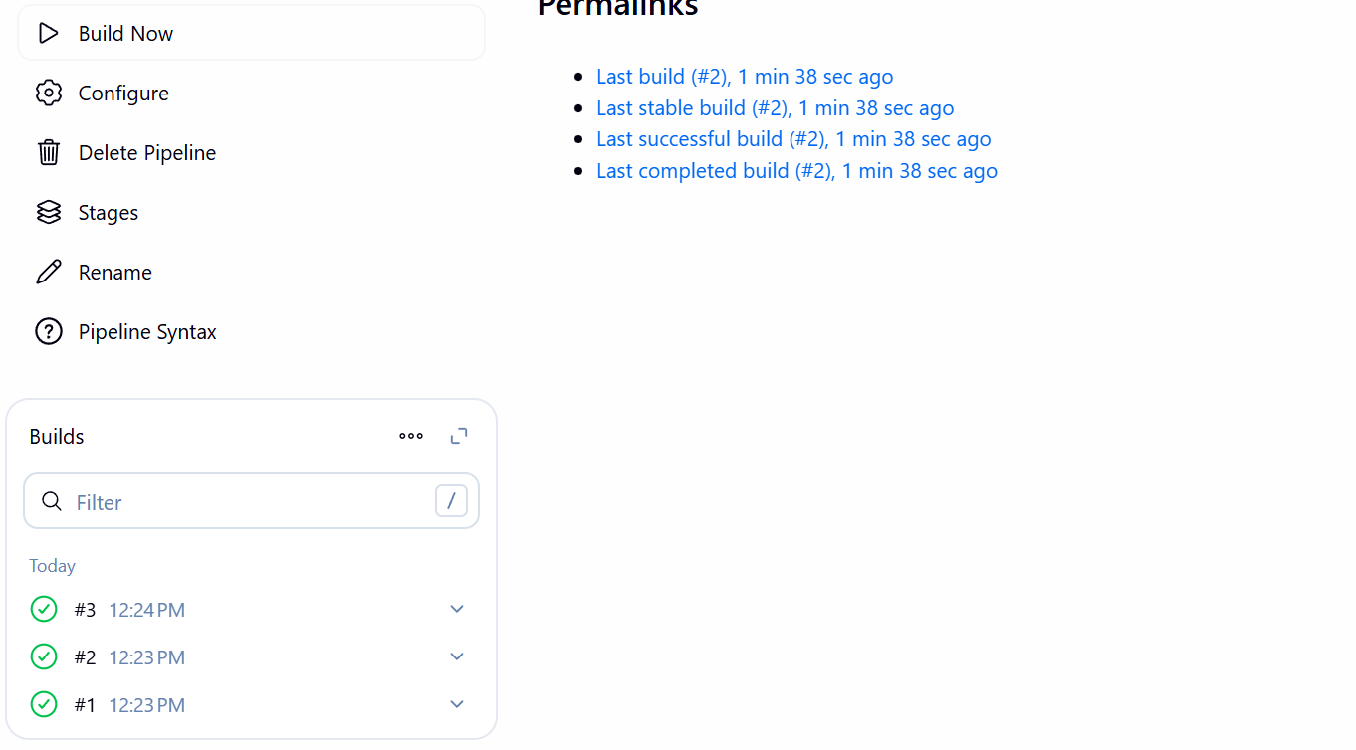
CONSOLE OUTPUT:
